**CO3 Programs**

1. Work with built-in packages.

**Program**

**Math.py**

import math

print("Factorial:",math.factorial(5))

print ("GCD:",math.gcd(4,12))

print ("sqrt:",math.sqrt(25))

OUTPUT:

Factorial: 120

GCD: 4

sqrt: 5.0

**Time.py**

import time

print("Current time in sec:",time.time())

print("Current time:",time.ctime())

print("Time After 30 sec:",time.ctime(time.time()+30)) t=time.localtime() print("Time:",t) print("Time-current year:",t.tm_year)

print("Time:-current month",t.tm_mon)

print("Time:-current day",t.tm_mday)

print("Time:-current hour",t.tm_hour)

print("Time:-current minute",t.tm_min)

print("Time:-current sec",t.tm_sec)

print("Time:-current week day",t.tm_wday)

print("Time:-current year day",t.tm_yday)

OUTPUT:

Current time in sec: 1639961383.5407367

Current time: Mon Dec 20 06:19:43 2021

Time After 30 sec: Mon Dec 20 06:20:13 2021

Time: time.struct_time(tm_year=2021, tm_mon=12, tm_mday=20, tm_hour=6, tm_min=19, tm_sec=43, tm_wday=0, tm_yday=354, tm_isdst=0)

Time-current year: 2021

Time:-current month 12

Time:-current day 20

Time:-current hour 6

Time:-current minute 19

Time:-current sec 43

Time:-current week day 0

Time:-current year day 354

**Dtime.py**

import datetime

t=datetime.time(22,56,20,67)

print(t)

print("Hour",t.hour)

print("Minutes",t.minute)

print("Seconds",t.second)

print("Microsecond:",t.microsecond)

print("\n")

d=datetime.date.today()

print("Today:",d)

print("Year:",d.year)

print("Month:",d.month)

print("Day:",d.day)

d1=datetime.date.today()

print(d1)

td=datetime.timedelta(days=2)

print(td)

d2=d1+td

print(d2)

dt=datetime.datetime.combine(d1,t)

print("date-time comb:",dt)

OUTPUT:

22:56:20.000067

Hour 22

Minutes 56

Seconds 20

Microsecond: 67

Today: 2021-12-20

Year: 2021

Month: 12

Day: 20

2021-12-20

2 days, 0:00:00

2021-12-22

date-time comb: 2021-12-20 22:56:20.000067

**Cal.py**

import calendar

mm=int(input("Enter month:"))

yy=int(input("Enter year:"))

print(calendar.month(yy,mm))

print(calendar.calendar(2021))

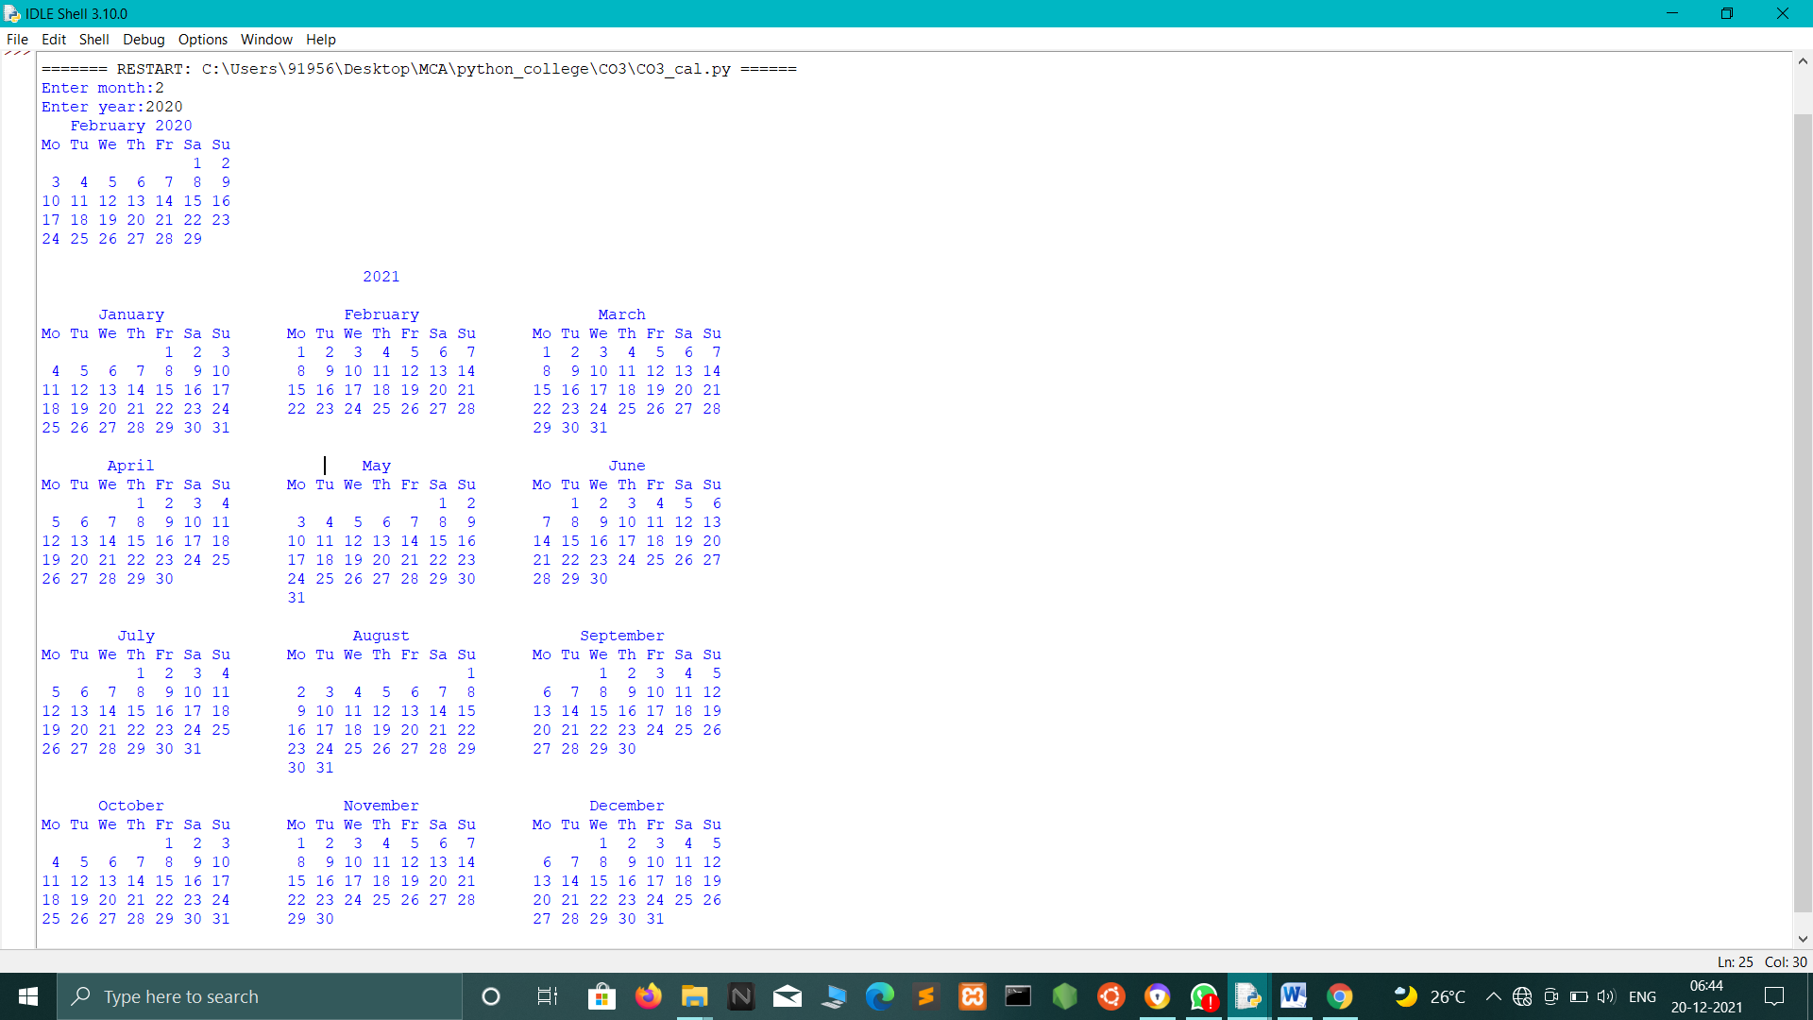

**Statistics.py**

import statistics

print("MEAN:",statistics.mean([2,4,7,6,10]))

print("MEDIAN:",statistics.median([1, 3, 5, 7, 9, 11, 13]))

print("MODE:",statistics.mode([1, 1, -3, 3, 7, -9]))

print("VARIENCE:",statistics.variance([1, 3, 5, 7, 9, 11]))

print("HARMONIC MEAN:",statistics.harmonic_mean([40, 60, 80]))

OUTPUT:

MEAN: 5.8

MEDIAN: 7

MODE: 1

VARIENCE: 14

HARMONIC MEAN: 55.38461538461538

**Random.py**

import random

print("seed:",random.seed(10))

print("random float:",random.random())

mylist = ["apple", "banana", "cherry"]

print("sample:",random.sample(mylist, k=2))

print(random.random())

mylist2 = ["apple", "banana", "cherry"]

random.shuffle(mylist2)

print("shuffle:",mylist2)

mylist3 = ["apple", "banana", "cherry"]

print("choice:",random.choice(mylist3))

OUTPUT:

seed: None

random float: 0.5714025946899135

sample: ['banana', 'cherry']

0.5780913011344704

shuffle: ['cherry', 'banana', 'apple']

choice: banana

1. Create a package graphics with modules rectangle, circle and sub-package 3D-graphics with modules cuboid and sphere. Include methods to find area and perimeter of respective figures in each module. Write programs that finds area and perimeter of figures by different importing statements. (Include selective import of modules and import * statements)

**Area.py**

from graphics import rectangle

from graphics import circle

from graphics import cuboid

from graphics import sphere

l=int(input("Enter the length of rectangle:"))

b=int(input("Enter the breadth of rectangle:"))

print("Area=",rectangle.area(l,b))

print("Perimeter=",rectangle.perimeter(l,b))

r=int(input("\nEnter the radius of circle:"))

print("Area=",circle.area(r))

print("Perimeter=",circle.perimeter(r))

l=int(input("\nEnter the length of cuboid:"))

w=int(input("Enter the width of cuboid:"))

h=int(input("Enter the height of cuboid:"))

b=int(input("Enter the breadth of cuboid:"))

print("Area=",cuboid.area(l,w,h))

print("perimeter=",cuboid.perimeter(l,b,h))

r=int(input("\nEnter the radius of sphere:"))

print("Area=",sphere.area(r))

print("perimeter=",sphere.perimeter(r))

**Graphics:**

**circle.py**

def area(r):

return(3.14*r*r)

def perimeter(r):

return(2*3.14*r)

**rectangle.py**

def area(l,b):

return(l*b)

def perimeter(l,b):

return(2*(l+b))

**cuboid.py**

def area(l,w,h):

return(2*l*w+2*l*h+2*h*w)

def perimeter(l,b,h):

return(4*(l+b+h))

**sphere.py**

def area(r):

return(4*3.14*r*r)

def perimeter(r):

return(2*3.14*r)

OUTPUT:

Enter the length of rectangle:4

Enter the breadth of rectangle:3

Area= 12

Perimeter= 14

Enter the radius of circle:2

Area= 12.56

Perimeter= 12.56

Enter the length of cuboid:4

Enter the width of cuboid:3

Enter the height of cuboid:5

Enter the breadth of cuboid:6

Area= 94

perimeter= 60

Enter the radius of sphere:4

Area= 200.96

perimeter= 25.12